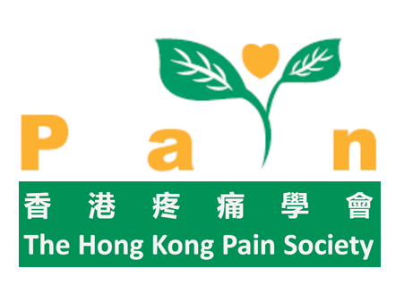

The Hong Kong Pain Society
Conference Grant Invitation

Overseas Conference related to Pain Management

Regular and life members of the Hong Kong Pain Society are invited to apply for the conference grant to attend international conference related to pain management and preferably involving multidisciplinary participation. The grant will cover the conference registration fees and return economy air-passage with a maximum of HKD15,000.00. Please find attached a copy of the HKPS Conference Grant Selection Criteria and Application Form.

Applicants should send or fax their application to:
Secretary, Hong Kong Pain Society, c/o Pain Management Centre, Block A1, Alice Ho Miu Ling Nethersole Hospital, Tai Po or Fax no. 2666 6773

Deadline of application: 10 April 2012

Successful applicants will be notified and the results will be posted on the HKPS website on or before 20 April 2012.

Enquiries can be directed to Hon. Secretary Email: painsec@hkpainsociety.org or Fax no. 2666 6773

Website: hkpainsociety.org.hk

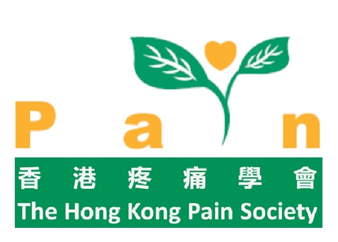 | The Hong Kong Pain Society  Conference Grant  Application Form

Overseas Conference related to Pain Management

Family Name: ________________________  Mobile/Telephone Contact: ______________ | Given Name: _________________________  Email: _______________________________
Profession: ___________________________ | Primary specialty/subspecialty: ___________
Correspondence Address: ______________________________________________________
___________________________________________________________________________
HKPS Member since: __________________
Have you received a conference grant from HKSP in the last 2 years? YES / NO
Are you receiving any sponsorship from other sources to this conference? YES / NO
(If yes, from which source: ________________ and amount: ____________________)
Amount of Grant applied:  Registration fees ________________  Air-passage ________________  Others ________________ | For official use only  Approved / Not approved (please circle)  Grant amount: $__________________________  ______________ ______________ ______________  Signatures

Write in 100 words why you wish to attend this conference (pls type).

Hong Kong Pain Society Conference Grant

Selection Guide 2012
From time to time, the Hong Kong Pain Society (HKPS) may invite applications from its members to apply for HKPS conference grants to attend local and overseas academic conferences.

The criteria for selection will include:
- The term "Conference" applies to local and overseas academic meeting.
- Preference will only be given to conferences related to pain medicine and management.
- Applicant must be a regular or life member of the HKPS for 1 year immediately prior to the application.
- Applicant must be a regular or life member of the HKPS during the time of conference.
- Preference will be given to applicants who have not received HKPS grant in the previous 2 years.
- Successful applicants will be subject to a 2 years’ exemption period for future HKPS Conference Grant and may be required to sign an undertaking form.
- Individuals who have already received partial or full funding/ sponsorship from other sources for the said conference may be considered but will be of a lower priority than those who have not received any sponsorship from other sources for the said conference.
- A report on the conference (400 words) must be submitted to the HKPS within 30 days after attending the conference, and may be published in the HKPS newsletter.
- Type of expenses to be sponsored will vary with different conferences and be announced in the invitation for application. The financing will be on a reimbursement basis for the actual expenses incurred in relation to attending the conference. Such expenses must not be reimbursed by any other organization.
- The reimbursement is subjected to adequate proofs of the expenditure submitted after attending the conference and the submission of the report to the Society.
- A Selection Committee comprising of three members of the Council of HKPS will decide and select the successful applicants for the conference grant.
- All decisions of the selection committee will be final.

